- PUBLISHED IN SOUTH LAKE TABLET 10-13 EDITION

Lake County Voters Alert
October 11, 2022
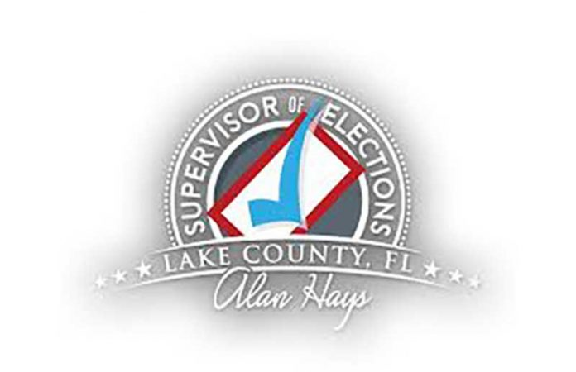
The Lake County Supervisor of Elections office would like to alert voters and businesses to phone calls and email communications being made by individuals who are not in any way associated with our office.
Lake County Supervisor Of Elections Alan Hays
These individuals are inquiring about voters’ record of voting for the 2022 Primary Election. Under the guise of being helpful, these individuals are claiming to attempt to clean up the voter rolls in Lake County and have even alluded to the possible identity theft of voters.
Lake County voters and businesses should be advised that these inquiries ARE NOT being conducted by the elections office and there is NO OBLIGATION to provide any information whatsoever. The actions of these individuals are irresponsible and simply contribute to the erosion of voter confidence and misinformation which continues to plague our elections system. Voters with concerns or questions regarding their voter record should contact our office at 352-343-9734.
As Lake County’s trusted source for election information, we remain focused on the successful administration of the November 8, 2022 General Election. Lake Countians can contribute to this success by updating their address, as well as reviewing their Voter Information Card, or visiting LakeVotes.gov for their specific precinct and polling locations.

